**OSPF**

**Single Area Network**

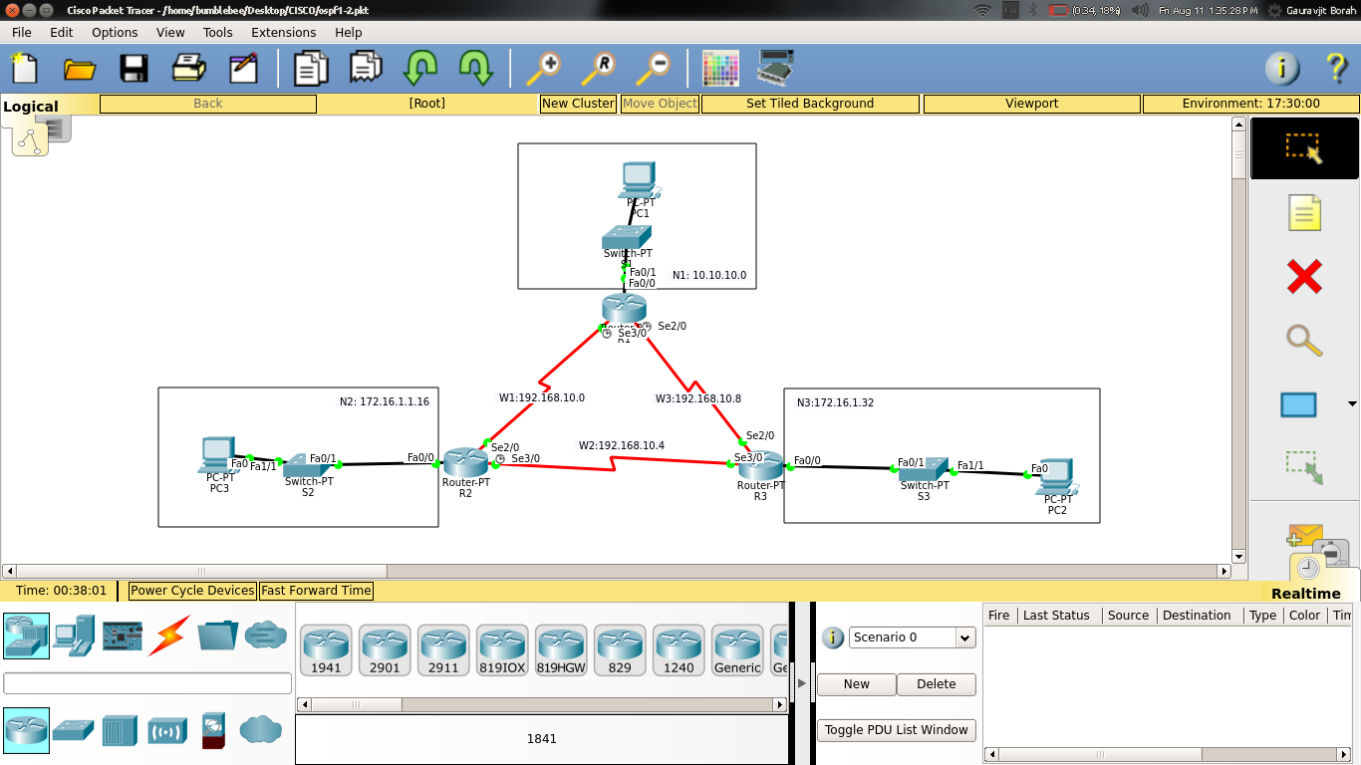

|  |  |  |  |  |  |  |
| --- | --- | --- | --- | --- | --- | --- |
| NAME | N/K ADDR | SUBNET MASK | WILDCARD M/K | CIDR | BROADCAST ADDR | Host Addr Range |
| N1 | 10.10.10.0 | 255.255.255.0 | 0.0.0.255 | 24 | 10.10.10.255 | 10.10.10.1-10.10.10.254 |
| N2 | 172.16.1.16 | 255.255.255.240 | 0.0.0.15 | 28 | 172.16.1.31 | 172.16.1.17-172.16.1.30 |
| N3 | 172.16.1.32 | 255.255.255.248 | 0.0.0.7 | 29 | 172.16.1.39 | 172.16.1.33-172.16.1.38 |
| W1 | 192.168.10.0 | 255.255.255.252 | 0.0.0.3 | 30 | 192.168.10.3 | 192.168.10.1-192.168.10.2 |
| W2 | 192.168.10.4 | 255.255.255.252 | 0.0.0.3 | 30 | 192.168.10.7 | 192.168.10.5-192.168.10.6 |
| W3 | 192.168.10.8 | 255.255.255.252 | 0.0.0.3 | 30 | 192.168.10.11 | 192.168.10.9-192.168.10.10 |

**SCENARIO 1**

**ROUTER 1**

R1#show ip route

Codes: C - connected, S - static, I - IGRP, R - RIP, M - mobile, B - BGP

D - EIGRP, EX - EIGRP external, O - OSPF, IA - OSPF inter area

N1 - OSPF NSSA external type 1, N2 - OSPF NSSA external type 2

E1 - OSPF external type 1, E2 - OSPF external type 2, E - EGP

i - IS-IS, L1 - IS-IS level-1, L2 - IS-IS level-2, ia - IS-IS inter area

* - candidate default, U - per-user static route, o - ODR

P - periodic downloaded static route

Gateway of last resort is not set

1.0.0.0/24 is subnetted, 1 subnets

C 1.1.1.0 is directly connected, Loopback1

10.0.0.0/24 is subnetted, 1 subnets

C 10.10.10.0 is directly connected, FastEthernet0/0

172.16.0.0/16 is variably subnetted, 2 subnets, 2 masks

O 172.16.1.16/28 [110/65] via 192.168.10.1, 00:18:06, Serial3/0

O 172.16.1.32/29 [110/65] via 192.168.10.10, 00:18:06, Serial2/0

192.168.10.0/30 is subnetted, 3 subnets

C 192.168.10.0 is directly connected, Serial3/0

O 192.168.10.4 [110/128] via 192.168.10.10, 00:18:06, Serial2/0

[110/128] via 192.168.10.1, 00:18:06, Serial3/0

C 192.168.10.8 is directly connected, Serial2/0

R1#show ip ospf

Routing Process "ospf 1" with ID 1.1.1.1

Supports only single TOS(TOS0) routes

Supports opaque LSA

SPF schedule delay 5 secs, Hold time between two SPFs 10 secs

Minimum LSA interval 5 secs. Minimum LSA arrival 1 secs

Number of external LSA 0. Checksum Sum 0x000000

Number of opaque AS LSA 0. Checksum Sum 0x000000

Number of DCbitless external and opaque AS LSA 0

Number of DoNotAge external and opaque AS LSA 0

Number of areas in this router is 1. 1 normal 0 stub 0 nssa

External flood list length 0

Area BACKBONE(0)

Number of interfaces in this area is 3

Area has no authentication

SPF algorithm executed 2 times

Area ranges are

Number of LSA 3. Checksum Sum 0x01f3c0

Number of opaque link LSA 0. Checksum Sum 0x000000

Number of DCbitless LSA 0

Number of indication LSA 0

Number of DoNotAge LSA 0

Flood list length 0

**ROUTER 2**

R2#show ip route

Codes: C - connected, S - static, I - IGRP, R - RIP, M - mobile, B - BGP

D - EIGRP, EX - EIGRP external, O - OSPF, IA - OSPF inter area

N1 - OSPF NSSA external type 1, N2 - OSPF NSSA external type 2

E1 - OSPF external type 1, E2 - OSPF external type 2, E - EGP

i - IS-IS, L1 - IS-IS level-1, L2 - IS-IS level-2, ia - IS-IS inter area

* - candidate default, U - per-user static route, o - ODR

P - periodic downloaded static route

Gateway of last resort is not set

1.0.0.0/24 is subnetted, 1 subnets

C 1.1.1.0 is directly connected, Loopback1

10.0.0.0/24 is subnetted, 1 subnets

O 10.10.10.0 [110/65] via 192.168.10.2, 00:19:26, Serial2/0

172.16.0.0/16 is variably subnetted, 2 subnets, 2 masks

C 172.16.1.16/28 is directly connected, FastEthernet0/0

O 172.16.1.32/29 [110/65] via 192.168.10.6, 00:19:26, Serial3/0

192.168.10.0/30 is subnetted, 3 subnets

C 192.168.10.0 is directly connected, Serial2/0

C 192.168.10.4 is directly connected, Serial3/0

O 192.168.10.8 [110/128] via 192.168.10.6, 00:19:26, Serial3/0

[110/128] via 192.168.10.2, 00:19:26, Serial2/0

**ROUTER 3**

R3#show ip route

Codes: C - connected, S - static, I - IGRP, R - RIP, M - mobile, B - BGP

D - EIGRP, EX - EIGRP external, O - OSPF, IA - OSPF inter area

N1 - OSPF NSSA external type 1, N2 - OSPF NSSA external type 2

E1 - OSPF external type 1, E2 - OSPF external type 2, E - EGP

i - IS-IS, L1 - IS-IS level-1, L2 - IS-IS level-2, ia - IS-IS inter area

* - candidate default, U - per-user static route, o - ODR

P - periodic downloaded static route

Gateway of last resort is not set

1.0.0.0/24 is subnetted, 1 subnets

C 1.1.1.0 is directly connected, Loopback1

10.0.0.0/24 is subnetted, 1 subnets

O 10.10.10.0 [110/65] via 192.168.10.9, 00:20:31, Serial2/0

172.16.0.0/16 is variably subnetted, 2 subnets, 2 masks

O 172.16.1.16/28 [110/65] via 192.168.10.5, 00:20:41, Serial3/0

C 172.16.1.32/29 is directly connected, FastEthernet0/0

192.168.10.0/30 is subnetted, 3 subnets

O 192.168.10.0 [110/128] via 192.168.10.5, 00:20:31, Serial3/0

[110/128] via 192.168.10.9, 00:20:31, Serial2/0

C 192.168.10.4 is directly connected, Serial3/0

C 192.168.10.8 is directly connected, Serial2/0

**SCENARIO 2**

**Case 1**

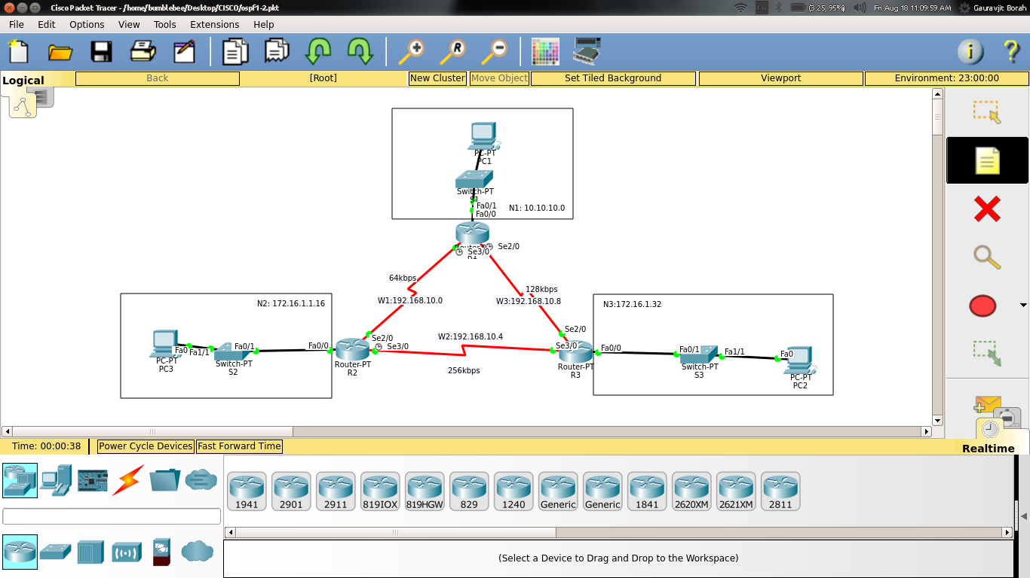

Bandwidth:

W1 = 64kbps

W2 = 256kbps

W3 = 128kbps

**ROUTER 1**

R1#show ip route

Codes: C - connected, S - static, I - IGRP, R - RIP, M - mobile, B - BGP

D - EIGRP, EX - EIGRP external, O - OSPF, IA - OSPF inter area

N1 - OSPF NSSA external type 1, N2 - OSPF NSSA external type 2

E1 - OSPF external type 1, E2 - OSPF external type 2, E - EGP

i - IS-IS, L1 - IS-IS level-1, L2 - IS-IS level-2, ia - IS-IS inter area

* - candidate default, U - per-user static route, o - ODR

P - periodic downloaded static route

Gateway of last resort is not set

1.0.0.0/24 is subnetted, 1 subnets

C 1.1.1.0 is directly connected, Loopback1

10.0.0.0/24 is subnetted, 1 subnets

C 10.10.10.0 is directly connected, FastEthernet0/0

172.16.0.0/16 is variably subnetted, 2 subnets, 2 masks

O 172.16.1.16/28 [110/455] via 192.168.10.10, 00:10:42, Serial2/0

O 172.16.1.32/29 [110/65] via 192.168.10.10, 00:10:42, Serial2/0

192.168.10.0/30 is subnetted, 3 subnets

C 192.168.10.0 is directly connected, Serial3/0

O 192.168.10.4 [110/454] via 192.168.10.10, 00:10:42, Serial2/0

C 192.168.10.8 is directly connected, Serial2/0

R1#show ip ospf

Routing Process "ospf 1" with ID 1.1.1.1

Supports only single TOS(TOS0) routes

Supports opaque LSA

SPF schedule delay 5 secs, Hold time between two SPFs 10 secs

Minimum LSA interval 5 secs. Minimum LSA arrival 1 secs

Number of external LSA 0. Checksum Sum 0x000000

Number of opaque AS LSA 0. Checksum Sum 0x000000

Number of DCbitless external and opaque AS LSA 0

Number of DoNotAge external and opaque AS LSA 0

Number of areas in this router is 1. 1 normal 0 stub 0 nssa

External flood list length 0

Area BACKBONE(0)

Number of interfaces in this area is 3

Area has no authentication

SPF algorithm executed 2 times

Area ranges are

Number of LSA 3. Checksum Sum 0x00d444

Number of opaque link LSA 0. Checksum Sum 0x000000

Number of DCbitless LSA 0

Number of indication LSA 0

Number of DoNotAge LSA 0

Flood list length 0

**ROUTER 2**

R2#show ip route

Codes: C - connected, S - static, I - IGRP, R - RIP, M - mobile, B - BGP

D - EIGRP, EX - EIGRP external, O - OSPF, IA - OSPF inter area

N1 - OSPF NSSA external type 1, N2 - OSPF NSSA external type 2

E1 - OSPF external type 1, E2 - OSPF external type 2, E - EGP

i - IS-IS, L1 - IS-IS level-1, L2 - IS-IS level-2, ia - IS-IS inter area

* - candidate default, U - per-user static route, o - ODR

P - periodic downloaded static route

Gateway of last resort is not set

1.0.0.0/24 is subnetted, 1 subnets

C 1.1.1.0 is directly connected, Loopback1

10.0.0.0/24 is subnetted, 1 subnets

O 10.10.10.0 [110/455] via 192.168.10.6, 00:10:42, Serial3/0

172.16.0.0/16 is variably subnetted, 2 subnets, 2 masks

C 172.16.1.16/28 is directly connected, FastEthernet0/0

O 172.16.1.32/29 [110/391] via 192.168.10.6, 00:10:42, Serial3/0

192.168.10.0/30 is subnetted, 3 subnets

C 192.168.10.0 is directly connected, Serial2/0

C 192.168.10.4 is directly connected, Serial3/0

O 192.168.10.8 [110/454] via 192.168.10.6, 00:10:42, Serial3/0

**ROUTER 3**

R3#show ip route

Codes: C - connected, S - static, I - IGRP, R - RIP, M - mobile, B - BGP

D - EIGRP, EX - EIGRP external, O - OSPF, IA - OSPF inter area

N1 - OSPF NSSA external type 1, N2 - OSPF NSSA external type 2

E1 - OSPF external type 1, E2 - OSPF external type 2, E - EGP

i - IS-IS, L1 - IS-IS level-1, L2 - IS-IS level-2, ia - IS-IS inter area

* - candidate default, U - per-user static route, o - ODR

P - periodic downloaded static route

Gateway of last resort is not set

1.0.0.0/24 is subnetted, 1 subnets

C 1.1.1.0 is directly connected, Loopback1

10.0.0.0/24 is subnetted, 1 subnets

O 10.10.10.0 [110/65] via 192.168.10.9, 00:08:49, Serial2/0

172.16.0.0/16 is variably subnetted, 2 subnets, 2 masks

O 172.16.1.16/28 [110/391] via 192.168.10.5, 00:08:59, Serial3/0

C 172.16.1.32/29 is directly connected, FastEthernet0/0

192.168.10.0/30 is subnetted, 3 subnets

O 192.168.10.0 [110/1626] via 192.168.10.9, 00:08:49, Serial2/0

C 192.168.10.4 is directly connected, Serial3/0

C 192.168.10.8 is directly connected, Serial2/0

**Case 2**

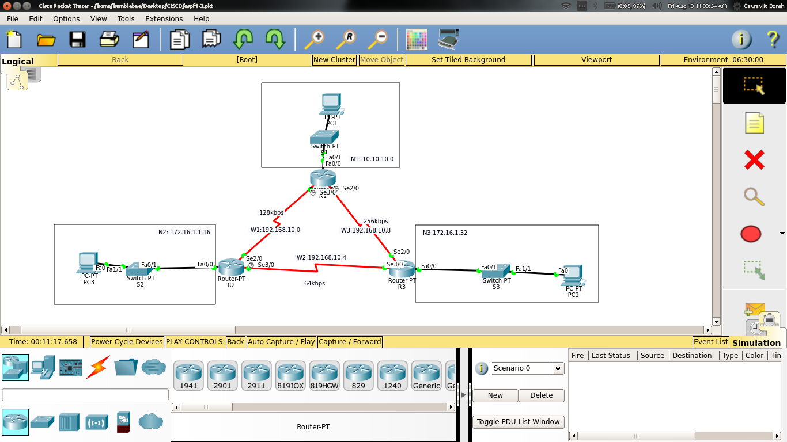

Bandwidth:

W1 = 128kbps

W2 = 64kbps

W3 = 256kbps

**ROUTER 1**

R1#show ip route

Codes: C - connected, S - static, I - IGRP, R - RIP, M - mobile, B - BGP

D - EIGRP, EX - EIGRP external, O - OSPF, IA - OSPF inter area

N1 - OSPF NSSA external type 1, N2 - OSPF NSSA external type 2

E1 - OSPF external type 1, E2 - OSPF external type 2, E - EGP

i - IS-IS, L1 - IS-IS level-1, L2 - IS-IS level-2, ia - IS-IS inter area

* - candidate default, U - per-user static route, o - ODR

P - periodic downloaded static route

Gateway of last resort is not set

1.0.0.0/24 is subnetted, 1 subnets

C 1.1.1.0 is directly connected, Loopback1

10.0.0.0/24 is subnetted, 1 subnets

C 10.10.10.0 is directly connected, FastEthernet0/0

172.16.0.0/16 is variably subnetted, 2 subnets, 2 masks

O 172.16.1.16/28 [110/782] via 192.168.10.1, 00:00:35, Serial3/0

O 172.16.1.32/29 [110/391] via 192.168.10.10, 00:01:28, Serial2/0

192.168.10.0/30 is subnetted, 3 subnets

C 192.168.10.0 is directly connected, Serial3/0

O 192.168.10.4 [110/1952] via 192.168.10.10, 00:00:35, Serial2/0

C 192.168.10.8 is directly connected, Serial2/0

**ROUTER 2**

R2#show ip route

Codes: C - connected, S - static, I - IGRP, R - RIP, M - mobile, B - BGP

D - EIGRP, EX - EIGRP external, O - OSPF, IA - OSPF inter area

N1 - OSPF NSSA external type 1, N2 - OSPF NSSA external type 2

E1 - OSPF external type 1, E2 - OSPF external type 2, E - EGP

i - IS-IS, L1 - IS-IS level-1, L2 - IS-IS level-2, ia - IS-IS inter area

* - candidate default, U - per-user static route, o - ODR

P - periodic downloaded static route

Gateway of last resort is not set

1.0.0.0/24 is subnetted, 1 subnets

C 1.1.1.0 is directly connected, Loopback1

10.0.0.0/24 is subnetted, 1 subnets

O 10.10.10.0 [110/782] via 192.168.10.2, 00:01:01, Serial2/0

172.16.0.0/16 is variably subnetted, 2 subnets, 2 masks

C 172.16.1.16/28 is directly connected, FastEthernet0/0

O 172.16.1.32/29 [110/1172] via 192.168.10.2, 00:01:01, Serial2/0

192.168.10.0/30 is subnetted, 3 subnets

C 192.168.10.0 is directly connected, Serial2/0

C 192.168.10.4 is directly connected, Serial3/0

O 192.168.10.8 [110/1171] via 192.168.10.2, 00:01:01, Serial2/0

**ROUTER 3**

R3#show ip route

Codes: C - connected, S - static, I - IGRP, R - RIP, M - mobile, B - BGP

D - EIGRP, EX - EIGRP external, O - OSPF, IA - OSPF inter area

N1 - OSPF NSSA external type 1, N2 - OSPF NSSA external type 2

E1 - OSPF external type 1, E2 - OSPF external type 2, E - EGP

i - IS-IS, L1 - IS-IS level-1, L2 - IS-IS level-2, ia - IS-IS inter area

* - candidate default, U - per-user static route, o - ODR

P - periodic downloaded static route

Gateway of last resort is not set

1.0.0.0/24 is subnetted, 1 subnets

C 1.1.1.0 is directly connected, Loopback1

10.0.0.0/24 is subnetted, 1 subnets

O 10.10.10.0 [110/391] via 192.168.10.9, 00:00:55, Serial2/0

172.16.0.0/16 is variably subnetted, 2 subnets, 2 masks

O 172.16.1.16/28 [110/1172] via 192.168.10.9, 00:00:55, Serial2/0

C 172.16.1.32/29 is directly connected, FastEthernet0/0

192.168.10.0/30 is subnetted, 3 subnets

O 192.168.10.0 [110/1171] via 192.168.10.9, 00:00:55, Serial2/0

C 192.168.10.4 is directly connected, Serial3/0

C 192.168.10.8 is directly connected, Serial2/0

**Case 3**

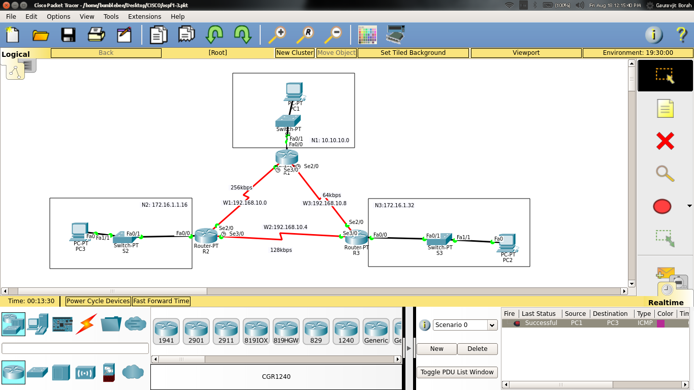

Bandwidth:

W1 = 256kbps

W2 = 128kbps

W3 = 64kbps

**ROUTER 1**

R1#show ip route

Codes: C - connected, S - static, I - IGRP, R - RIP, M - mobile, B - BGP

D - EIGRP, EX - EIGRP external, O - OSPF, IA - OSPF inter area

N1 - OSPF NSSA external type 1, N2 - OSPF NSSA external type 2

E1 - OSPF external type 1, E2 - OSPF external type 2, E - EGP

i - IS-IS, L1 - IS-IS level-1, L2 - IS-IS level-2, ia - IS-IS inter area

* - candidate default, U - per-user static route, o - ODR

P - periodic downloaded static route

Gateway of last resort is not set

1.0.0.0/24 is subnetted, 1 subnets

C 1.1.1.0 is directly connected, Loopback1

10.0.0.0/24 is subnetted, 1 subnets

C 10.10.10.0 is directly connected, FastEthernet0/0

172.16.0.0/16 is variably subnetted, 2 subnets, 2 masks

O 172.16.1.16/28 [110/391] via 192.168.10.1, 00:16:38, Serial3/0

O 172.16.1.32/29 [110/1172] via 192.168.10.1, 00:15:55, Serial3/0

192.168.10.0/30 is subnetted, 3 subnets

C 192.168.10.0 is directly connected, Serial3/0

O 192.168.10.4 [110/1171] via 192.168.10.1, 00:15:55, Serial3/0

C 192.168.10.8 is directly connected, Serial2/0

**ROUTER 2**

R2#show ip route

Codes: C - connected, S - static, I - IGRP, R - RIP, M - mobile, B - BGP

D - EIGRP, EX - EIGRP external, O - OSPF, IA - OSPF inter area

N1 - OSPF NSSA external type 1, N2 - OSPF NSSA external type 2

E1 - OSPF external type 1, E2 - OSPF external type 2, E - EGP

i - IS-IS, L1 - IS-IS level-1, L2 - IS-IS level-2, ia - IS-IS inter area

* - candidate default, U - per-user static route, o - ODR

P - periodic downloaded static route

Gateway of last resort is not set

1.0.0.0/24 is subnetted, 1 subnets

C 1.1.1.0 is directly connected, Loopback1

10.0.0.0/24 is subnetted, 1 subnets

O 10.10.10.0 [110/391] via 192.168.10.2, 00:16:41, Serial2/0

172.16.0.0/16 is variably subnetted, 2 subnets, 2 masks

C 172.16.1.16/28 is directly connected, FastEthernet0/0

O 172.16.1.32/29 [110/782] via 192.168.10.6, 00:16:28, Serial3/0

192.168.10.0/30 is subnetted, 3 subnets

C 192.168.10.0 is directly connected, Serial2/0

C 192.168.10.4 is directly connected, Serial3/0

O 192.168.10.8 [110/1952] via 192.168.10.2, 00:16:28, Serial2/0

**ROUTER 3**

R3#show ip route

Codes: C - connected, S - static, I - IGRP, R - RIP, M - mobile, B - BGP

D - EIGRP, EX - EIGRP external, O - OSPF, IA - OSPF inter area

N1 - OSPF NSSA external type 1, N2 - OSPF NSSA external type 2

E1 - OSPF external type 1, E2 - OSPF external type 2, E - EGP

i - IS-IS, L1 - IS-IS level-1, L2 - IS-IS level-2, ia - IS-IS inter area

* - candidate default, U - per-user static route, o - ODR

P - periodic downloaded static route

Gateway of last resort is not set

1.0.0.0/24 is subnetted, 1 subnets

C 1.1.1.0 is directly connected, Loopback1

10.0.0.0/24 is subnetted, 1 subnets

O 10.10.10.0 [110/1172] via 192.168.10.5, 00:16:34, Serial3/0

172.16.0.0/16 is variably subnetted, 2 subnets, 2 masks

O 172.16.1.16/28 [110/782] via 192.168.10.5, 00:16:34, Serial3/0

C 172.16.1.32/29 is directly connected, FastEthernet0/0

192.168.10.0/30 is subnetted, 3 subnets

O 192.168.10.0 [110/1171] via 192.168.10.5, 00:16:34, Serial3/0

C 192.168.10.4 is directly connected, Serial3/0

C 192.168.10.8 is directly connected, Serial2/0

**SCENARIO 3**

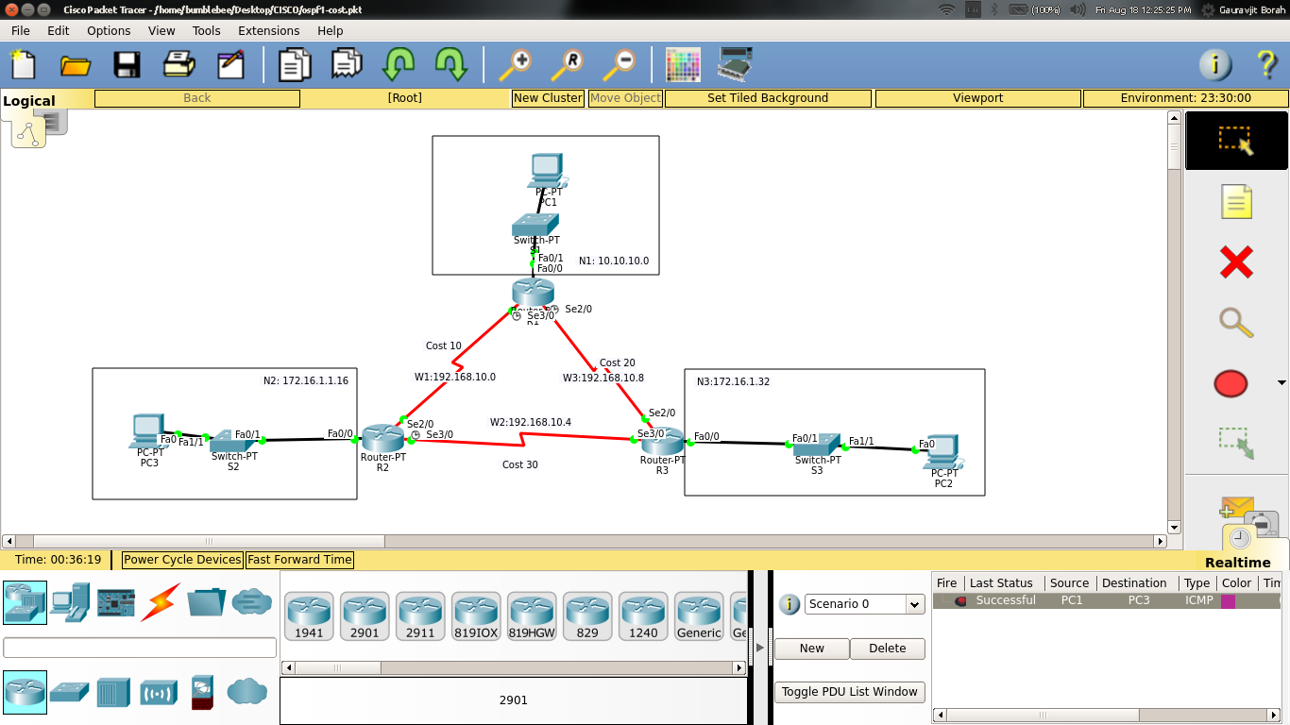

**Cost:**

W1 = 10

W2 = 30

W3 = 20

**ROUTER 1**

R1#show ip route

Codes: C - connected, S - static, I - IGRP, R - RIP, M - mobile, B - BGP

D - EIGRP, EX - EIGRP external, O - OSPF, IA - OSPF inter area

N1 - OSPF NSSA external type 1, N2 - OSPF NSSA external type 2

E1 - OSPF external type 1, E2 - OSPF external type 2, E - EGP

i - IS-IS, L1 - IS-IS level-1, L2 - IS-IS level-2, ia - IS-IS inter area

* - candidate default, U - per-user static route, o - ODR

P - periodic downloaded static route

Gateway of last resort is not set

1.0.0.0/24 is subnetted, 1 subnets

C 1.1.1.0 is directly connected, Loopback1

10.0.0.0/24 is subnetted, 1 subnets

C 10.10.10.0 is directly connected, FastEthernet0/0

172.16.0.0/16 is variably subnetted, 2 subnets, 2 masks

O 172.16.1.16/28 [110/11] via 192.168.10.1, 00:07:03, Serial3/0

O 172.16.1.32/29 [110/21] via 192.168.10.10, 00:06:52, Serial2/0

192.168.10.0/30 is subnetted, 3 subnets

C 192.168.10.0 is directly connected, Serial3/0

O 192.168.10.4 [110/40] via 192.168.10.1, 00:06:17, Serial3/0

C 192.168.10.8 is directly connected, Serial2/0

R1#show ip ospf

Routing Process "ospf 1" with ID 1.1.1.1

Supports only single TOS(TOS0) routes

Supports opaque LSA

SPF schedule delay 5 secs, Hold time between two SPFs 10 secs

Minimum LSA interval 5 secs. Minimum LSA arrival 1 secs

Number of external LSA 0. Checksum Sum 0x000000

Number of opaque AS LSA 0. Checksum Sum 0x000000

Number of DCbitless external and opaque AS LSA 0

Number of DoNotAge external and opaque AS LSA 0

Number of areas in this router is 1. 1 normal 0 stub 0 nssa

External flood list length 0

Area BACKBONE(0)

Number of interfaces in this area is 3

Area has no authentication

SPF algorithm executed 8 times

Area ranges are

Number of LSA 3. Checksum Sum 0x01c0ff

Number of opaque link LSA 0. Checksum Sum 0x000000

Number of DCbitless LSA 0

Number of indication LSA 0

Number of DoNotAge LSA 0

Flood list length 0

**ROUTER 2**

R2#show ip route

Codes: C - connected, S - static, I - IGRP, R - RIP, M - mobile, B - BGP

D - EIGRP, EX - EIGRP external, O - OSPF, IA - OSPF inter area

N1 - OSPF NSSA external type 1, N2 - OSPF NSSA external type 2

E1 - OSPF external type 1, E2 - OSPF external type 2, E - EGP

i - IS-IS, L1 - IS-IS level-1, L2 - IS-IS level-2, ia - IS-IS inter area

* - candidate default, U - per-user static route, o - ODR

P - periodic downloaded static route

Gateway of last resort is not set

1.0.0.0/24 is subnetted, 1 subnets

C 1.1.1.0 is directly connected, Loopback1

10.0.0.0/24 is subnetted, 1 subnets

O 10.10.10.0 [110/11] via 192.168.10.2, 00:06:47, Serial2/0

172.16.0.0/16 is variably subnetted, 2 subnets, 2 masks

C 172.16.1.16/28 is directly connected, FastEthernet0/0

O 172.16.1.32/29 [110/31] via 192.168.10.6, 00:06:37, Serial3/0

[110/31] via 192.168.10.2, 00:06:37, Serial2/0

192.168.10.0/30 is subnetted, 3 subnets

C 192.168.10.0 is directly connected, Serial2/0

C 192.168.10.4 is directly connected, Serial3/0

O 192.168.10.8 [110/30] via 192.168.10.2, 00:06:47, Serial2/0

**ROUTER 3**

R3#show ip route

Codes: C - connected, S - static, I - IGRP, R - RIP, M - mobile, B - BGP

D - EIGRP, EX - EIGRP external, O - OSPF, IA - OSPF inter area

N1 - OSPF NSSA external type 1, N2 - OSPF NSSA external type 2

E1 - OSPF external type 1, E2 - OSPF external type 2, E - EGP

i - IS-IS, L1 - IS-IS level-1, L2 - IS-IS level-2, ia - IS-IS inter area

* - candidate default, U - per-user static route, o - ODR

P - periodic downloaded static route

Gateway of last resort is not set

1.0.0.0/24 is subnetted, 1 subnets

C 1.1.1.0 is directly connected, Loopback1

10.0.0.0/24 is subnetted, 1 subnets

O 10.10.10.0 [110/21] via 192.168.10.9, 00:07:09, Serial2/0

172.16.0.0/16 is variably subnetted, 2 subnets, 2 masks

O 172.16.1.16/28 [110/31] via 192.168.10.5, 00:07:09, Serial3/0

[110/31] via 192.168.10.9, 00:07:09, Serial2/0

C 172.16.1.32/29 is directly connected, FastEthernet0/0

192.168.10.0/30 is subnetted, 3 subnets

O 192.168.10.0 [110/30] via 192.168.10.9, 00:07:09, Serial2/0

C 192.168.10.4 is directly connected, Serial3/0

C 192.168.10.8 is directly connected, Serial2/0